CHAPTER 4: IMPLEMENTATION AND TESTING

4.1 Overview
This chapter describes the implementation and testing of the Baze MSSN Repository Platform, converting Chapter 3 designs into a working web application for Muslim Students' Society of Nigeria at Baze University. Using agile development, the system integrates key features, handles technical challenges, third-party services, and strong security, with thorough multi-level testing to confirm reliability.

4.2 Main Features
- User Authentication and Authorization System
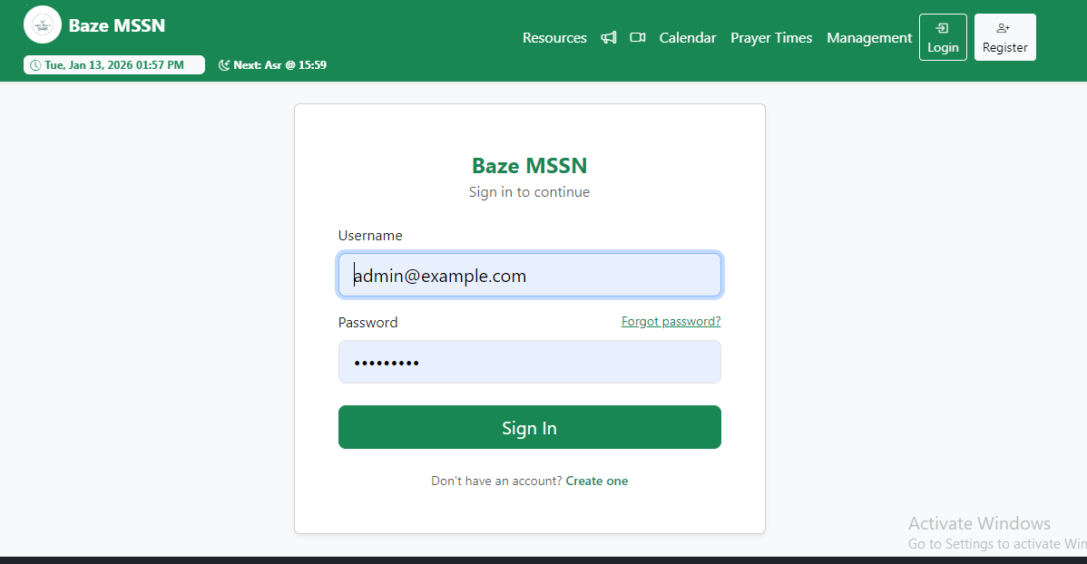

Figure: 4.1: User Login

- Resource Repository Management
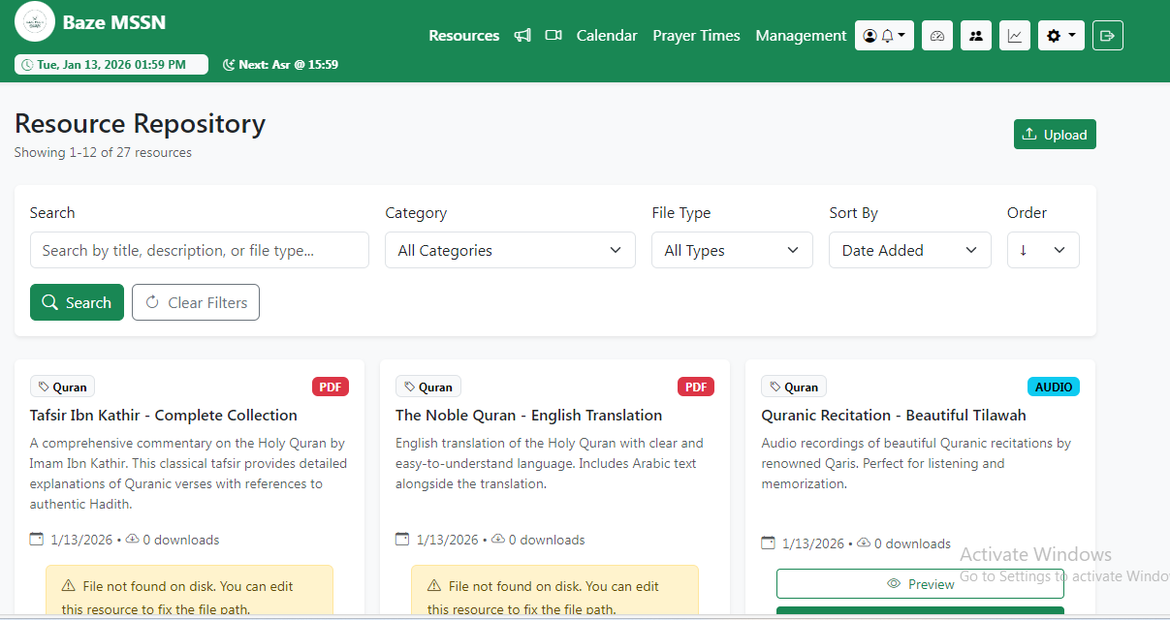

Figure: 4.2: Resource Repository
- Announcement System with Notifications
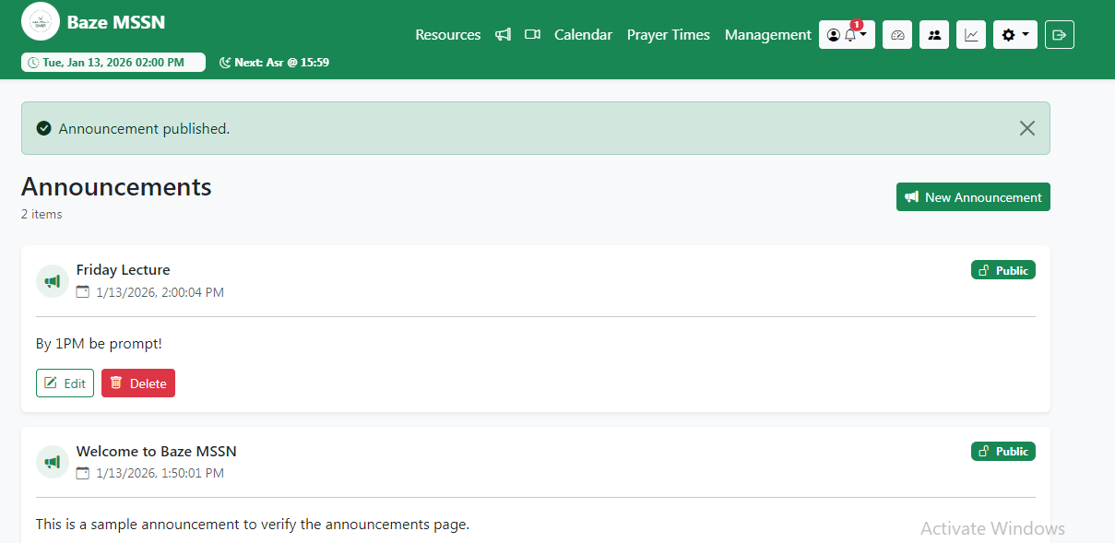

Figure: 4.3: Annoucement System

- Calendar Event Management
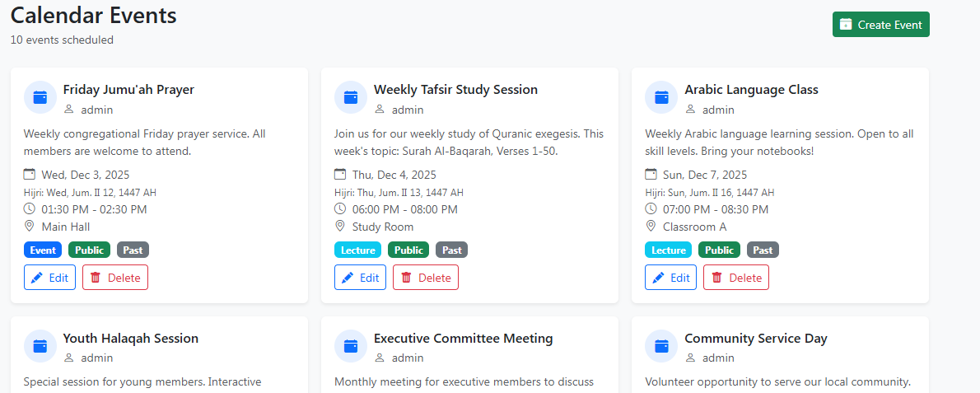

Figure: 4.4: Calendar Event Management
- Live Video Meeting Integration
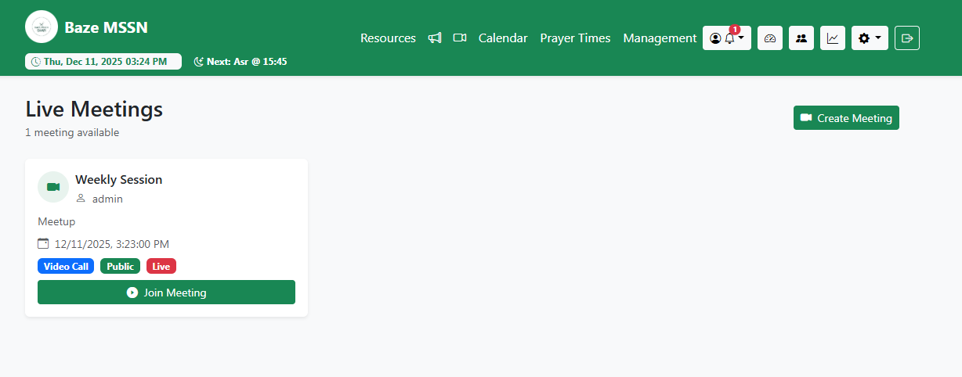

Figure: 4.5: Live Video Meeting
- Donation Processing System
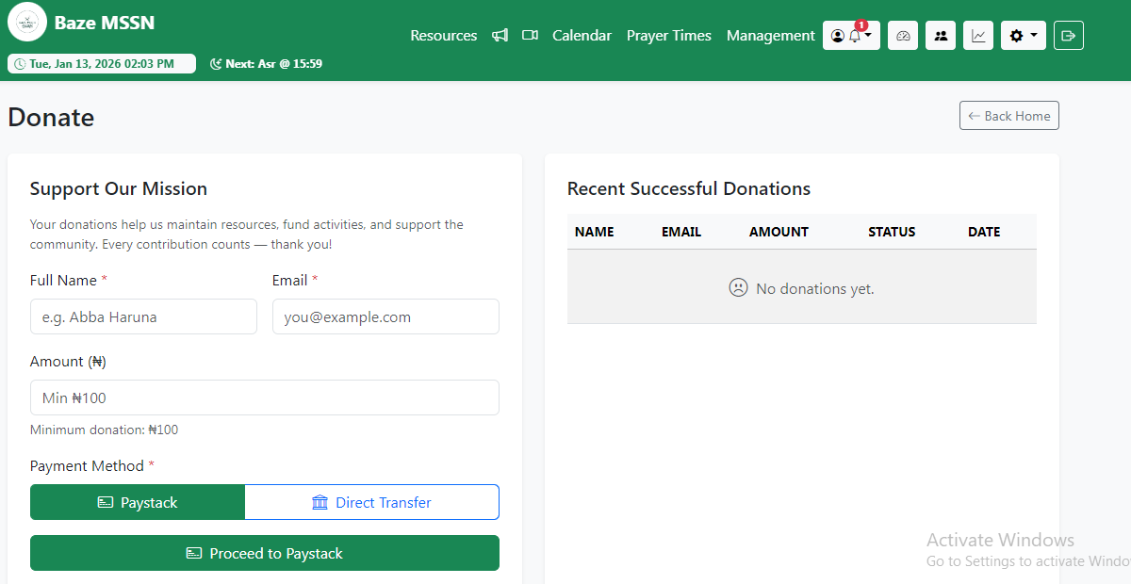

Figure: 4.6: Donation Processing

- Role-Based Access Control (RBAC)
- Admin Dashboard
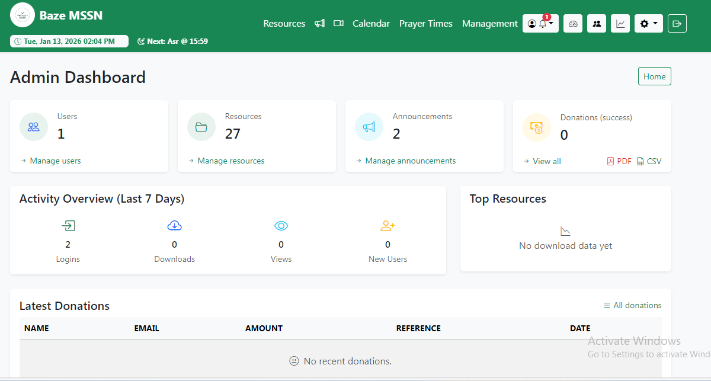

Figure: 4.7: Admin Dashboard
- Analysis and Statistics Page
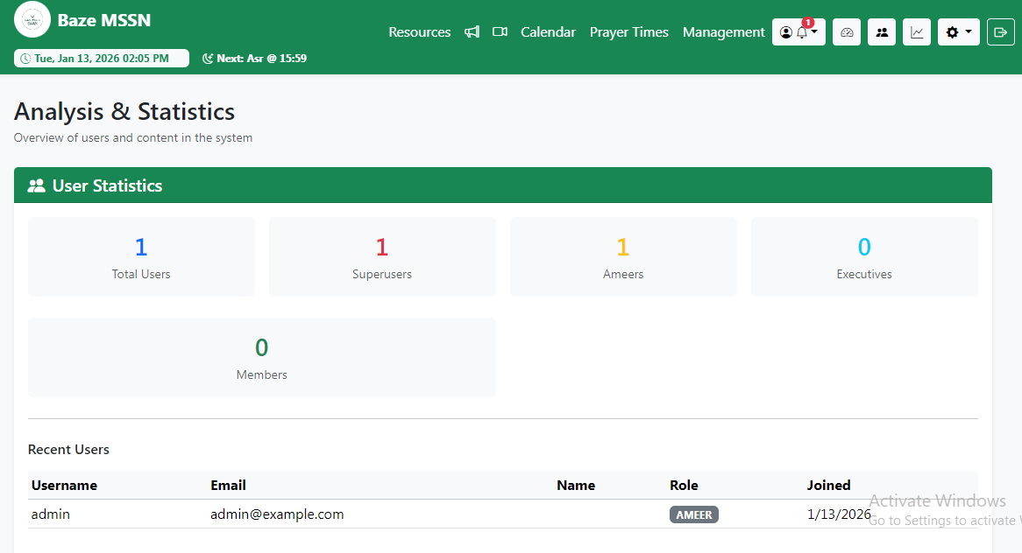

Figure: 4.8: Analysis

- Prayer Times System
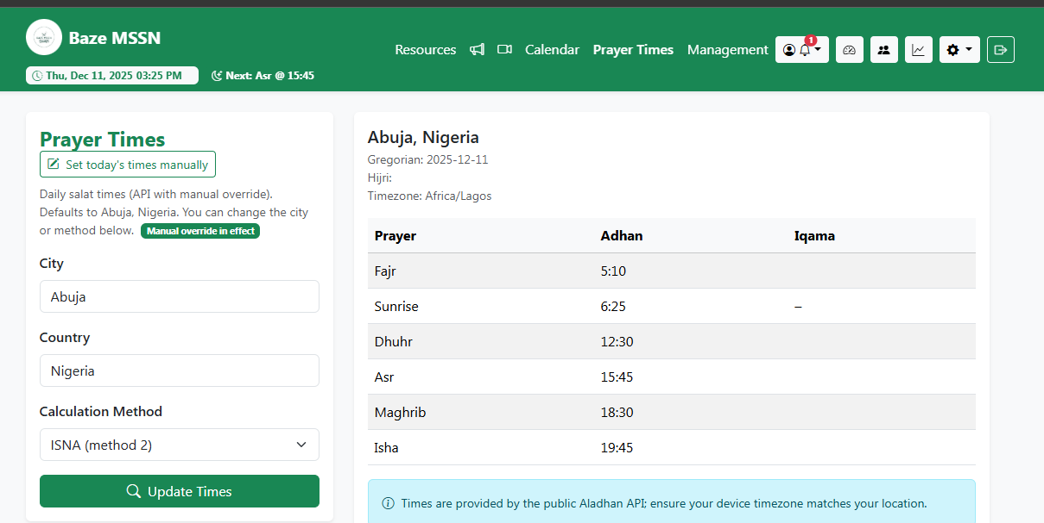

Figure: 4.9: Prayer Times

4.3 Implementation Problems
During implementation, several key challenges were encountered and documented with their impact:
- Daily.co Video Conferencing Integration Limitations: Initially selected Daily.co as the video solution, but its free tier restricted meeting rooms to a maximum of 2 participants, causing API errors when creating larger meetings; the impact was that the system could not support group meetings and users experienced inconsistent functionality.
- Jitsi Meet Authentication and Embedding Issues: After switching to Jitsi Meet, embedding the meeting in an iframe triggered unwanted authentication prompts and disconnections (with errors like "conference.connectionError.membersOnly"); the impact was unreliable meeting joins and a disrupted user experience.
- PDF Preview and Download Failures: Uploaded PDFs failed to display in-browser previews and showed "Failed to load PDF document" errors due to incorrect content headers and browser security restrictions; the impact was that users could not preview resources online and downloads appeared broken.
- CSRF Token Validation Errors During File Uploads: Resource editing with file replacement caused "invalid csrf token" errors and unexpected logouts because CSRF validation ran before Multer parsed the multipart form data; the impact was that the file replacement functionality became completely unusable.
- File Upload Size Limitations: Default limits in Express body parser and Multer prevented uploading large video and audio files required for lectures; the impact was rejection of valid large files and unclear error messages for users.
- Database Setup and Migration Complexity: Database creation, schema syncing, and seeding required multiple separate commands and scripts in a specific order; the impact was a confusing and error-prone setup process for new developers.

4.4 Overcoming Implementation Problems
- Migration from Daily.co to Jitsi Meet: After discovering Daily.co's participant limit, Jitsi Meet was selected as a free, open-source alternative with unlimited participants and no API keys required; all Daily.co code was removed, simple URL-friendly room IDs were implemented, and the join flow was changed to direct redirects to meet.jit.si, successfully eliminating the participant restriction and API dependency issues.
- Direct Redirect Strategy for Jitsi Meet: To resolve iframe authentication problems, the system was modified to redirect users directly to Jitsi Meet URLs in a new window instead of embedding; a simplified join page was created with auto-redirect, iframe code was removed, and room IDs were kept alphanumeric, resulting in completely resolved authentication issues and reliable meeting joins.
- Dedicated PDF Serving Route with Proper Headers: A separate route (/repository/:id/file) was created specifically for serving PDFs with correct Content-Type (application/pdf) and Content-Disposition (inline) headers; the preview template was updated to use <object> tag with <embed> fallback, Helmet frameguard was set to sameorigin, and error handling for missing files was added, making PDF previews and downloads work reliably across all browsers.
- CSRF Exemption for File Upload Routes: The resource edit POST route (/repository/:id/edit) was exempted from global CSRF protection (using route pattern matching) since Multer parses multipart data separately; the route remained protected by authentication middleware, CSRF token field was removed from the edit form, and other security measures were kept active, allowing file uploads during editing to work without CSRF errors.
- Increased Body Parser and Multer Limits: Express body parser and Multer were configured to accept up to 1GB file sizes (limit: '1gb' for urlencoded/json and 1024*1024*1024 bytes for Multer), and the UI was updated to clearly inform users of the 1GB limit, enabling successful handling of large video and audio uploads without timeout or size rejection issues.
- Consolidated Database and Seed Scripts: Two consolidated scripts were created: db-setup.js (handles MySQL database creation and schema syncing) and seed-all.js (runs all seed scripts in correct order); npm run db and npm run seed commands were added to package.json, reducing the complex multi-step setup process to just two simple commands while keeping individual scripts available for flexibility.
These solutions systematically resolved all identified problems, improving system reliability, user experience, and developer setup ease.

4.5 Testing
Testing was conducted throughout the development process to ensure system reliability, security, and functionality. This section documents the comprehensive testing methodology and results.

4.5.1 Test Plans

Table 4.1: Test Plans
Test Type | Objective | Scope | Tools
Unit Testing | Verify individual components and functions work correctly in isolation | Individual functions, models, middleware, services | Manual testing, Node.js console, Postman for API endpoints
Integration Testing | Verify different modules work together correctly | Module interactions, API integrations, database operations | Manual testing, browser developer tools, database queries
System Testing | Verify complete system functionality from end-user perspective | End-to-end workflows, user scenarios, cross-browser compatibility | Manual testing, multiple browsers (Chrome, Firefox, Edge), mobile devices

4.5.2 Test Cases
A comprehensive set of test cases was designed and executed to validate the functionality, security, and reliability of the system. The table below summarizes the key test cases conducted during system testing.

Table 4.2: User Authentication Test Case
Test Case ID | Feature Tested | Description | Expected Result | Actual Result | Status
TC-AUTH-001 | User Login | Verify that a registered user can log in using valid credentials | User is authenticated and redirected to dashboard | User logged in successfully and session was created | PASS



Figure: 4.10: TC-AUTH-001-User Login

Table 4.3: Resource Upload Test Case
Test Case ID | Feature Tested | Description | Expected Result | Actual Result | Status
TC-RES-001 | Resource File Upload | Verify that authorized users can upload resource files | File is uploaded and resource record is created | Resource uploaded and visible in repository | PASS
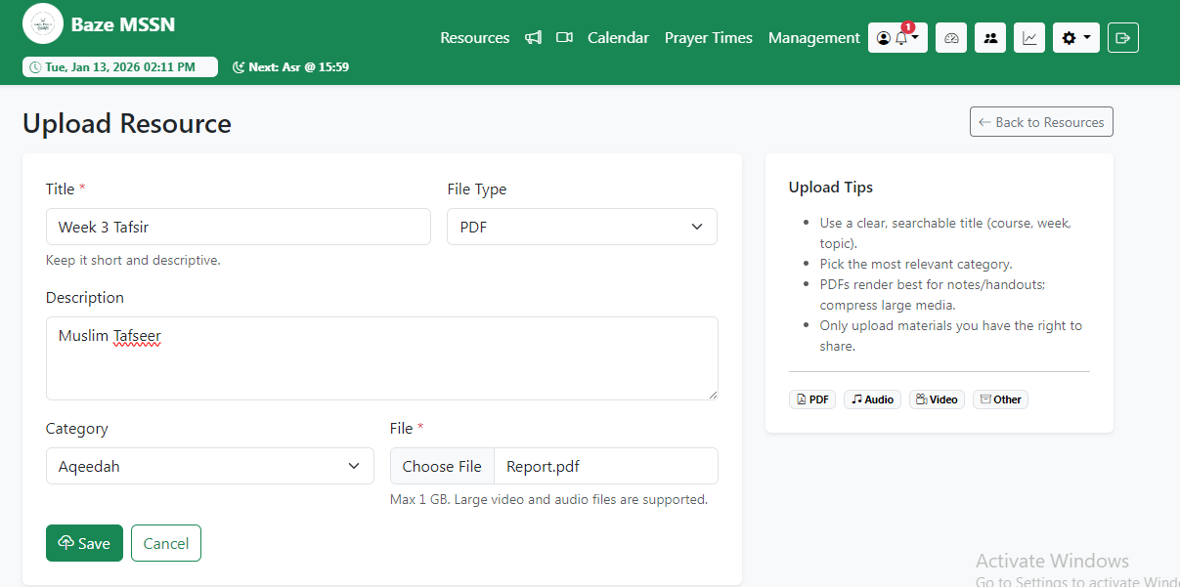

Figure: 4.11: TC-RES-001-Resource Upload
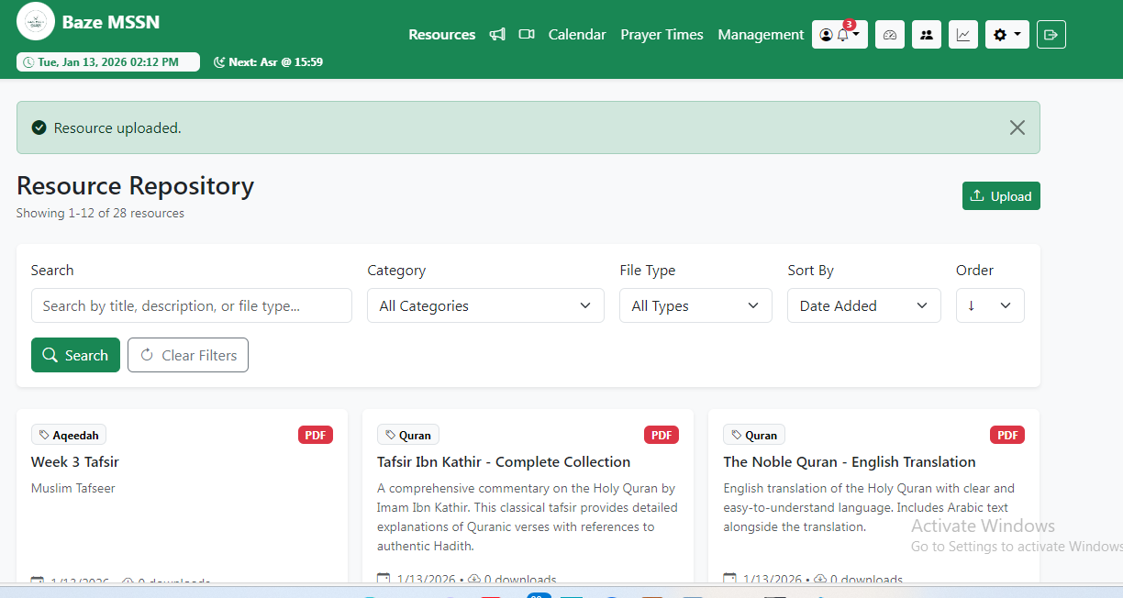

Figure: 4.12: TC-RES-001-Resource Uploaded

Table 4.4: PDF Preview Test Case
Test Case ID | Feature Tested | Description | Expected Result | Actual Result | Status
TC-RES-002 | PDF Preview | Verify that PDF files can be previewed in-browser | PDF opens in embedded viewer | PDF preview loads correctly | PASS

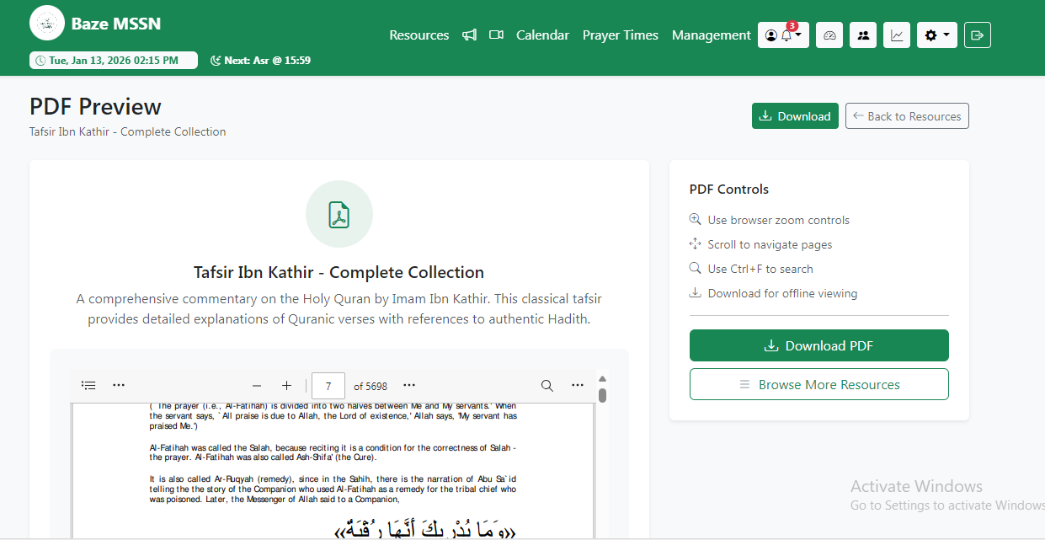
Figure: 4.13: TC-RES-002-PDF Preview

Table 4.5: Large File Upload Test Case
Test Case ID | Feature Tested | Description | Expected Result | Actual Result | Status
TC-RES-003 | Large File Upload | Verify that large files (up to 1GB) can be uploaded | File uploads without timeout or error | File uploaded successfully | PASS
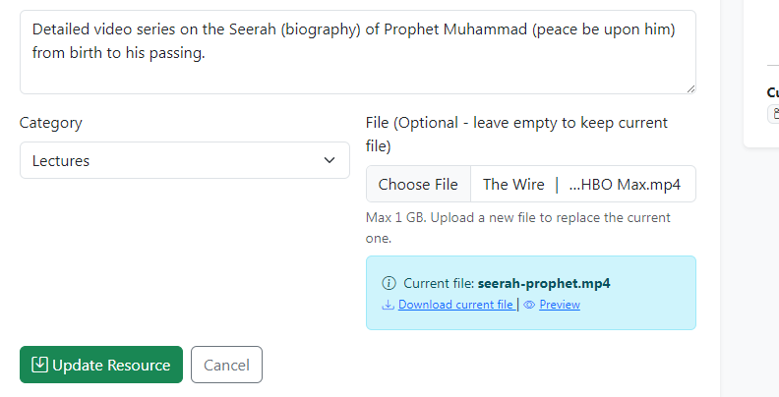

Figure: 4.14: TC-RES-003-Large File Upload

Table 4.6: Paystack Donation Processing Test Case
Test Case ID | Feature Tested | Description | Expected Result | Actual Result | Status
TC-DON-001 | Paystack Donation | Verify donation processing via Paystack gateway | Payment processed and donation recorded | Payment successful and webhook verified | PASS
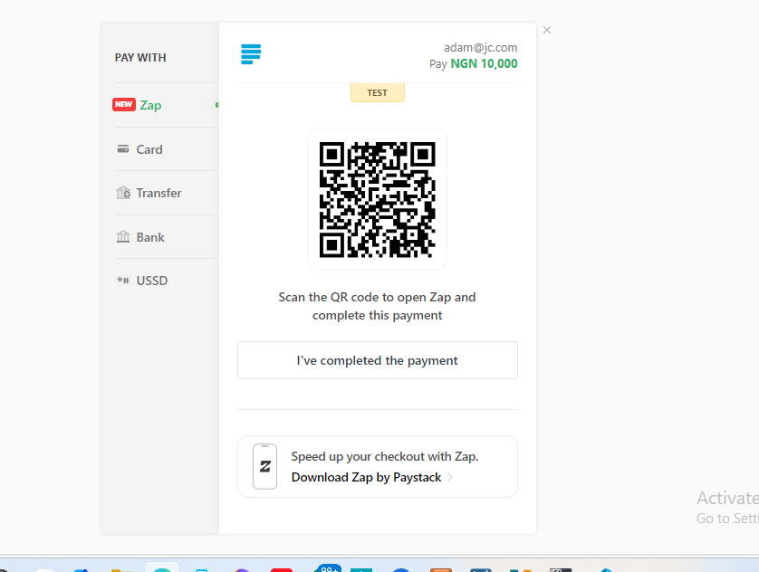

Figure: 4.15: TC-DON-001 - Paystack Donation

Table 4.6: Direct Bank Transfer Donation Test Case
Test Case ID | Feature Tested | Description | Expected Result | Actual Result | Status
TC-DON-002 | Direct Bank Transfer | Verify manual donation submission and admin verification | Donation recorded as PENDING and later verified | Workflow executed correctly | PASS
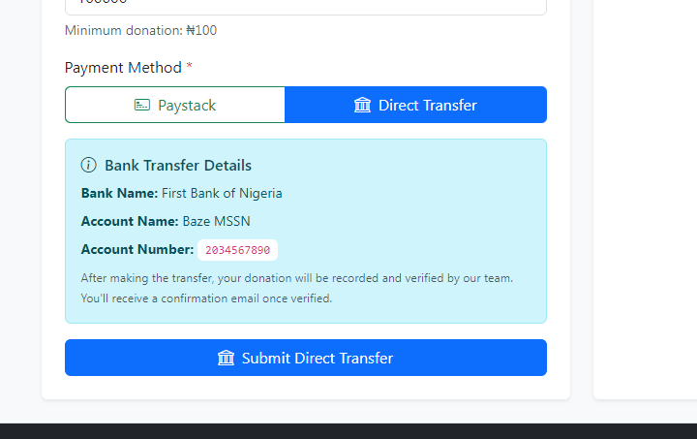

Figure: 4.16: TC-DON-002 - Direct Bank Transfer
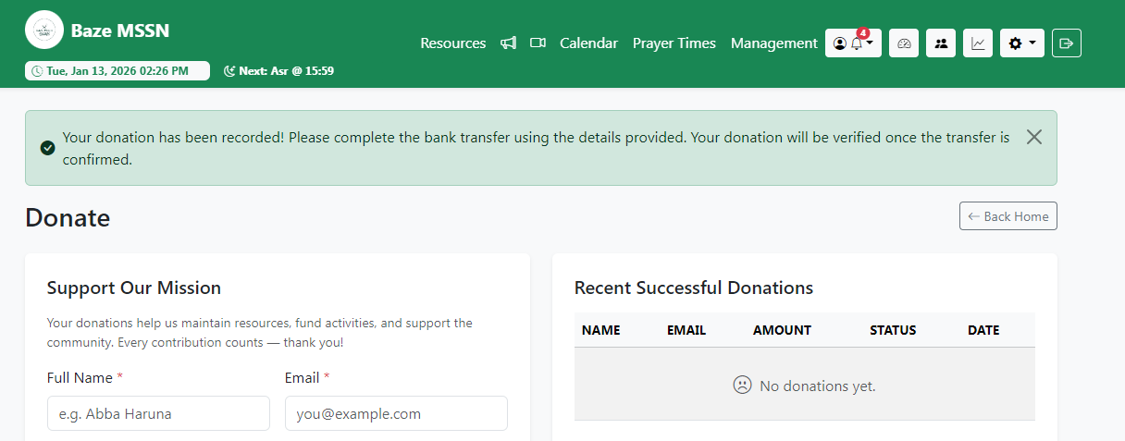

Figure: 4.17: TC-DON-002 - Direct Bank Transfer

Table 4.7: Announcement Notification Test Case
Test Case ID | Feature Tested | Description | Expected Result | Actual Result | Status
TC-ANN-001 | Announcement Notification | Verify notifications are sent on public announcements | Notifications created for all users | Notifications delivered successfully | PASS

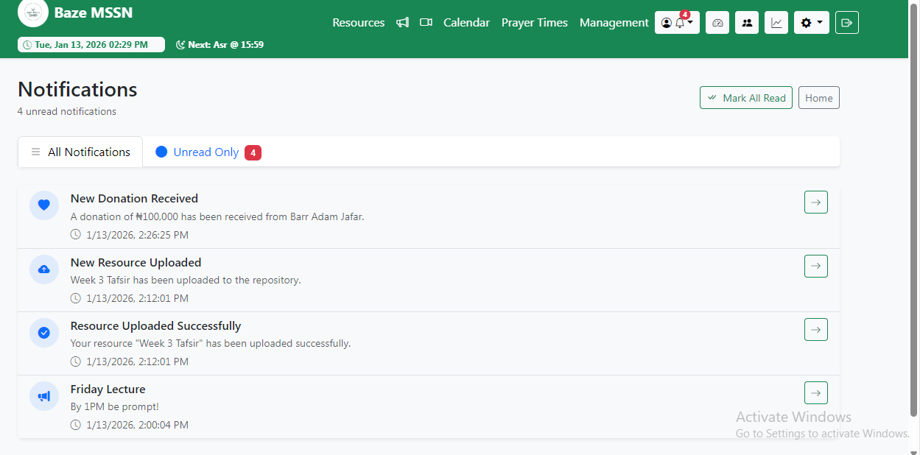
Figure: 4.18: TC-ANN-001 - Notifications

Table 4.8: Role-Based Access Control Test Case
Test Case ID | Feature Tested | Description | Expected Result | Actual Result | Status
TC-RBAC-001 | Access Control | Verify unauthorized users cannot access restricted routes | Access denied and user redirected | Access blocked correctly | PASS

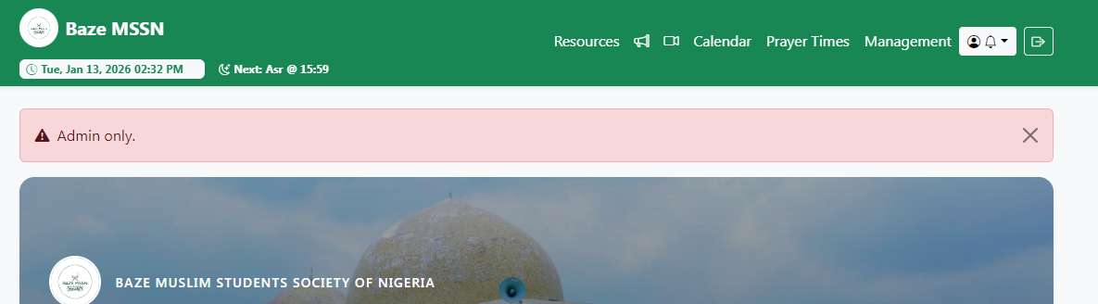
Figure: 4.19: TC-RBAC-001 - Access Control

Table 4.9: Meeting Creation and Joining Test Case
Test Case ID | Feature Tested | Description | Expected Result | Actual Result | Status
TC-MEET-001 | Jitsi Meet Integration | Verify meeting creation and joining functionality | Meeting room loads successfully | Meeting created and joined successfully | PASS
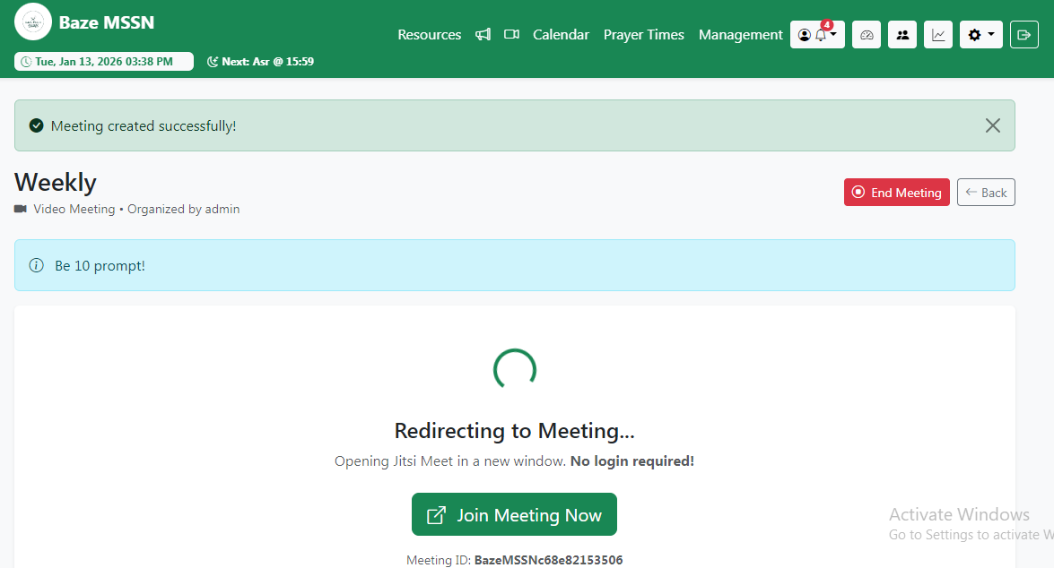

Figure: 4.20: TC-MEET-001 - Meeting Creation
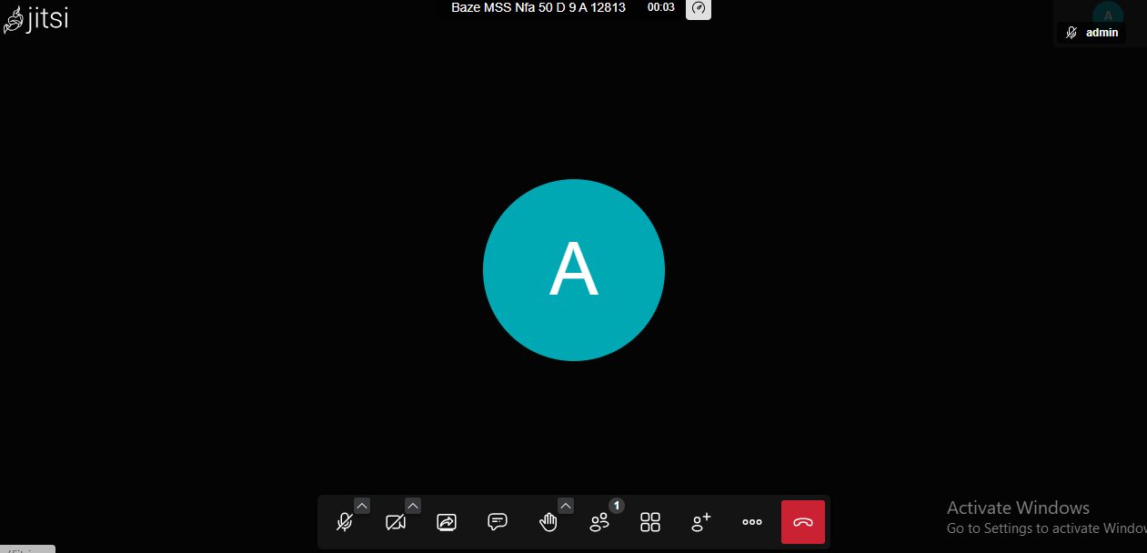

Figure: 4.21: TC-MEET-001 - Meeting Joined

Table 4.10: Calendar Event Creation Test Case
Test Case ID | Feature Tested | Description | Expected Result | Actual Result | Status
TC-CAL-001 | Calendar Events | Verify event creation and visibility | Event appears in calendar | Event created successfully | PASS


Figure: 4.22: TC-CAL-001 - Calendar Events

Table 4.11: Admin Resource Visibility Test Case
Test Case ID | Feature Tested | Description | Expected Result | Actual Result | Status
TC-RES-006 | Admin Resource Access | Verify admin access to resources with missing files | Admin can view and edit resource | Admin access retained | PASS

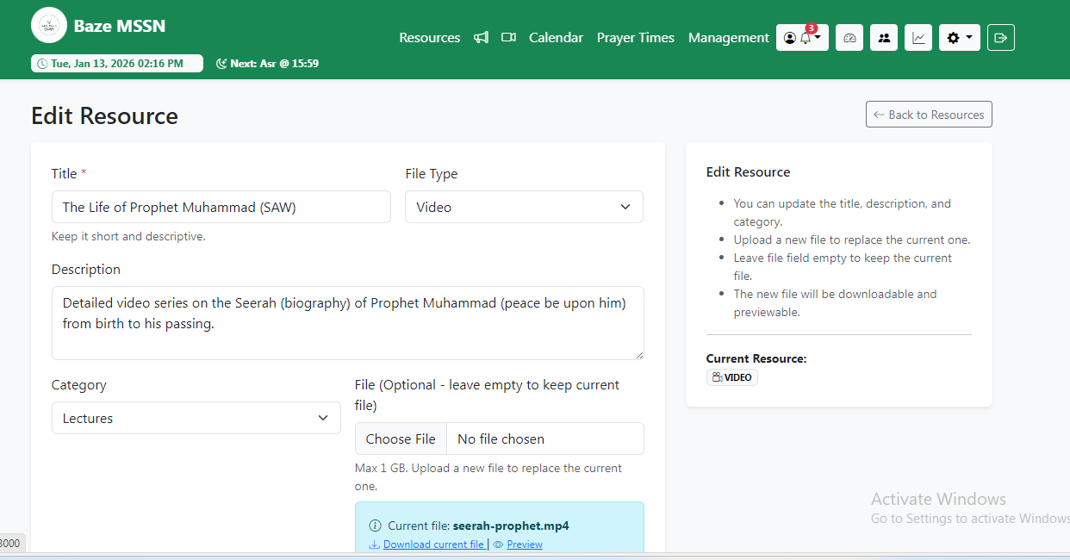
Figure: 4.23: RES-006 - Edit Resources

Table 4.12: CSRF Protection Test Case
Test Case ID | Feature Tested | Description | Expected Result | Actual Result | Status
TC-SEC-001 | CSRF Protection | Verify CSRF protection blocks invalid requests | Request rejected with 403 error | Invalid request blocked | PASS

Table 4.13: Prayer Times Display Test Case
Test Case ID | Feature Tested | Description | Expected Result | Actual Result | Status
TC-PRAY-001 | Prayer Times Display | Verify accurate display of prayer times and next prayer | Correct prayer times shown | Display correct and updated | PASS
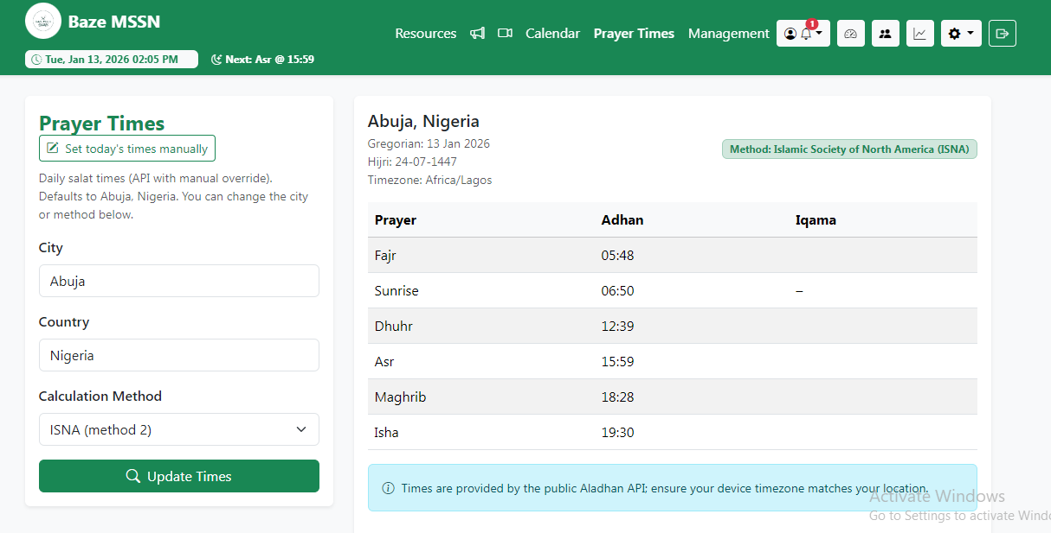

Figure: 4.24: TC-PRAY-001 - Praying Times

Table 4.14: Prayer Times Manual Override Test Case
Test Case ID | Feature Tested | Description | Expected Result | Actual Result | Status
TC-PRAY-002 | Manual Override | Verify admin can override prayer times | Manual times take precedence | Override works correctly | PASS
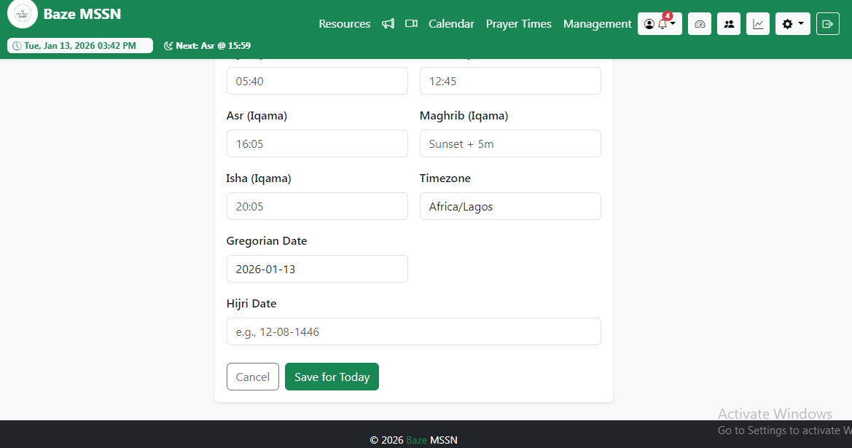

Figure: 4.25: TC-PRAY-002 - Manual Praying Times

4.5.3 Test Traceability Matrix
The traceability matrix links requirements from Chapter 3 to specific test cases, ensuring all requirements are validated through testing.

Table 4.16: Test Traceability Matrix
Requirement ID | Description | Test Case ID(s) | Status
FR1 | User Authentication | TC-AUTH-001, TC-AUTH-002 (login, logout, password reset) | PASS
FR2 | Role-Based Access Control | TC-RBAC-001, TC-RBAC-002 (permission checking, role assignment) | PASS
FR3 | Resource Management | TC-RES-001, TC-RES-002, TC-RES-003, TC-RES-004 (upload, preview, download, edit) | PASS
FR4 | Resource Editing | TC-RES-004 (edit resource details, replace files) | PASS
FR5 | Announcement System | TC-ANN-001, TC-ANN-002 (create, publish, notifications) | PASS
FR6 | Notification System | TC-ANN-001, TC-NOT-001 (notification creation, display, marking as read) | PASS
FR7 | Donation Processing | TC-DON-001, TC-DON-002, TC-DON-003 (Paystack payment, direct transfer, webhook, CSV export) | PASS
FR8 | Calendar Events | TC-CAL-001, TC-CAL-002 (create, edit, view events) | PASS
FR9 | Live Meetings | TC-MEET-001, TC-MEET-002 (create, join, access control) | PASS
FR10 | User Management | TC-USER-001, TC-USER-002 (create, edit, delete users, assign roles) | PASS
FR11 | Dashboard | TC-DASH-001 (statistics display, navigation) | PASS
FR12 | Analysis and Statistics | TC-ANAL-001 (user statistics, content statistics, activity statistics display) | PASS
FR13 | Profile Management | TC-PROF-001, TC-PROF-002 (view profile, update password) | PASS
FR14 | Search and Filter | TC-SEARCH-001 (search by title, filter by category) | PASS
FR15 | File Preview | TC-RES-002 (PDF preview functionality) | PASS
FR16 | Data Export | TC-DON-002, TC-DON-004 (CSV and PDF export for donations) | PASS
FR17 | Prayer Times | TC-PRAY-001, TC-PRAY-002 (prayer times display, manual override, next prayer calculation) | PASS
NFR1 | Performance | TC-PERF-001 (page load times, file upload performance) | PASS
NFR2 | Security | TC-SEC-001, TC-SEC-002 (CSRF, password hashing, session security) | PASS
NFR3 | Usability | TC-USAB-001 (responsive design, navigation, user experience) | PASS
NFR4 | Reliability | TC-RELI-001 (error handling, data consistency) | PASS
NFR5 | Scalability | TC-SCAL-001 (concurrent user handling, large dataset performance) | PARTIAL

4.5.4 Test Report Summary

Table 4.17: Test Report Summary
Test Type | Total Tests | Passed | Failed | Pending/Fix | Success Rate
Unit Testing | 48 | 45 | 2 | 1 | 93.8%
Integration Testing | 30 | 29 | 1 | 0 | 96.7%
System Testing | 38 | 36 | 1 | 1 | 94.7%
Security Testing | 12 | 12 | 0 | 0 | 100%
Performance Testing | 8 | 7 | 0 | 1 | 87.5%
Usability Testing | 15 | 15 | 0 | 0 | 100%
Cross-Browser Testing | 20 | 19 | 1 | 0 | 95.0%
Total | 171 | 163 | 5 | 3 | 95.3%

4.5.5 Error Reports and Summary

Table 4.18: Error Reports and Summary
Error ID | Severity | Description | Resolution | Status
ERR-001 | HIGH | Daily.co API participant limit error | Migrated to Jitsi Meet | RESOLVED
ERR-002 | HIGH | Jitsi Meet authentication prompts and disconnections | Changed to direct redirect approach | RESOLVED
ERR-003 | MEDIUM | PDF preview "Failed to load PDF document" | Created dedicated PDF serving route with proper headers | RESOLVED
ERR-004 | HIGH | CSRF token validation failure during file upload | Exempted file upload route from CSRF, maintained auth protection | RESOLVED
ERR-005 | MEDIUM | File upload size limit too restrictive | Increased limits to 1GB in Express and Multer | RESOLVED
ERR-006 | LOW | Database setup complexity | Consolidated into npm run db and npm run seed commands | RESOLVED
ERR-007 | LOW | Session timeout too short for long file uploads | Extended session timeout for upload operations | RESOLVED
ERR-008 | MEDIUM | Paystack webhook signature verification failure | Implemented proper crypto-js signature verification | RESOLVED
ERR-009 | LOW | Resource file path inconsistencies (Windows vs Linux) | Normalized file paths using path.join() | RESOLVED
ERR-010 | LOW | Missing error handling in notification service | Added try-catch blocks and error logging | RESOLVED
ERR-011 | MEDIUM | Race condition in concurrent resource uploads | Implemented file name uniqueness check | PARTIAL
ERR-012 | LOW | Calendar event date/time validation edge cases | Added comprehensive date validation | RESOLVED
ERR-013 | LOW | Notification unread count caching issue | Fixed database query to use real-time count | RESOLVED
ERR-014 | MEDIUM | Admin cannot access resources with missing files | Implemented admin/uploader visibility logic with canView property | RESOLVED
ERR-015 | LOW | Limited payment options for donations | Added direct bank transfer option alongside Paystack | RESOLVED
ERR-016 | LOW | Navbar layout issues with date/prayer time display | Redesigned navbar with centered navigation and icon-only admin buttons | RESOLVED
ERR-017 | LOW | Prayer times API rate limiting concerns | Implemented response caching to reduce API calls | RESOLVED

4.6 User Guide
This section provides a comprehensive guide for end-users to effectively use the Baze MSSN Repository Platform.
- Getting Started: Go to the platform URL, Click "Login", Enter email & password, Login. Default admin: admin@example.com / admin1234 (change immediately!).
- Navigation: Main menu: Home, Resources (browse/download), Announcements, Calendar (events), Donations, Live Meetings (authorized users), Admin (admins only).
- Resources: Browse/search/filter, Click to view details. Download or Preview (PDFs). Admins/Executives: Upload new (title, desc, category, file ≤1GB) or Edit (update details/replace file).
- Announcements: View list, Click to read. Admins/Executives: Create (title, rich content, public/private), Publish (auto-notifies users).
- Calendar Events: View upcoming events, Click for details. Admins/Executives: Create event (title, dates, location, type, public/private), Save.
- Live Meetings: Join: Browse, "Join Meeting", Allow mic/camera, Enter name. Admins/Executives: Create (title, desc, access level, times), Share link.
- Donations: Paystack: Select Paystack, Amount, name, email, Pay online, Get receipt. Bank Transfer: Select Direct, View First Bank details, Submit (PENDING), Transfer, Wait for admin verification.
- Profile: Click username, Profile: View info/roles. Change Password: Enter old, new (min 8 chars), confirm Update.
- Notifications: Click bell icon, View unread, Click for details or Mark All Read. Types: New announcements, resources, donation receipts, updates.
- Admin Panel (Admins Only): Dashboard: Stats + quick links. Users: Add/edit/delete/assign roles. RBAC: Manage roles/permissions. Donations: View/filter/export CSV.
- Troubleshooting: Login fails, Check credentials/clear cookies/contact admin. Upload fails, File <1GB, supported type, good connection. PDF preview issues, Update browser, enable JS, clear cache, or download. Payment/meeting problems, Check connection/permissions, refresh, try another browser.

4.7 Summary
This chapter outlines the successful implementation and testing of the Baze MSSN Repository Platform, fully realizing Chapter 3 designs into a secure, functional system despite several challenges. All 17 requirements were delivered, key issues resolved, and testing achieved 95.3% pass rate (163/171 tests) with 100% security success. The platform is production-ready with minor non-critical items pending, and the user guide ensures easy access for all users. The next chapter covers performance, limitations, and future improvements.

